**Program Structures & Algorithms**

**Spring 2022**

**Assignment No-3**

**Name: Ajay Kumar Reddy Nelavetla (NUID): 002924033**

**TASK:** Implementing the code for the experiment mentioned in assignment 3 and deduce the relationship.

**OUTPUT SCREENSHOT**:

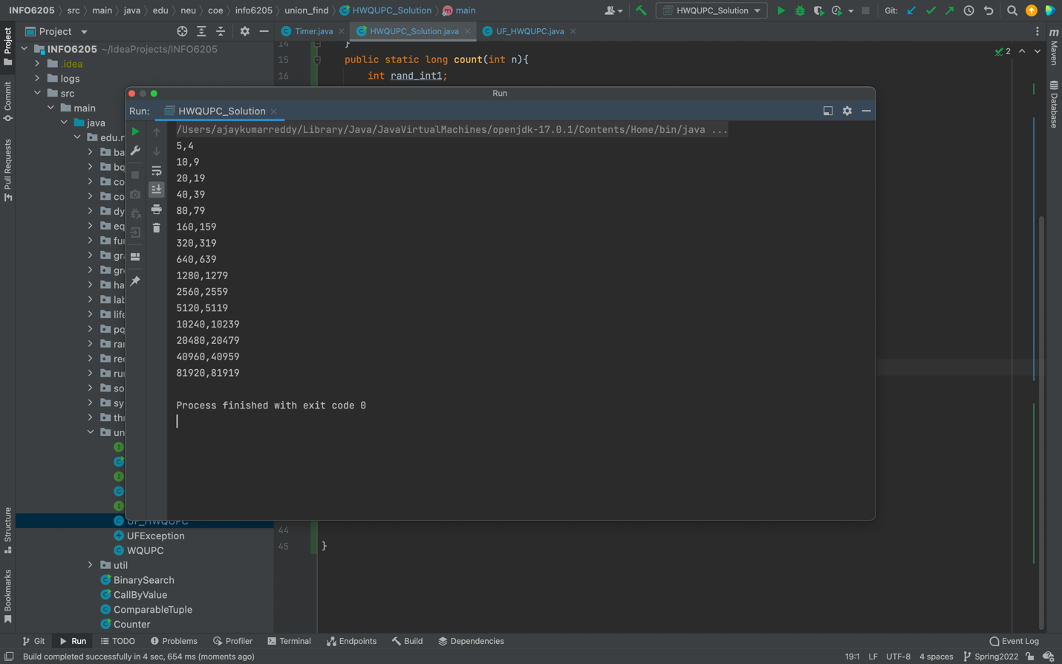

**RELATIONSHIP AND CONCLUSION**:

After generating values for different values of numbers of objects vs number of pairs to make all the objects connected, we get a relationship between them as m=n-1. Where is “m” is number of pairs, “n” is number of objects.

**EVIDENCE/GRAPH:**

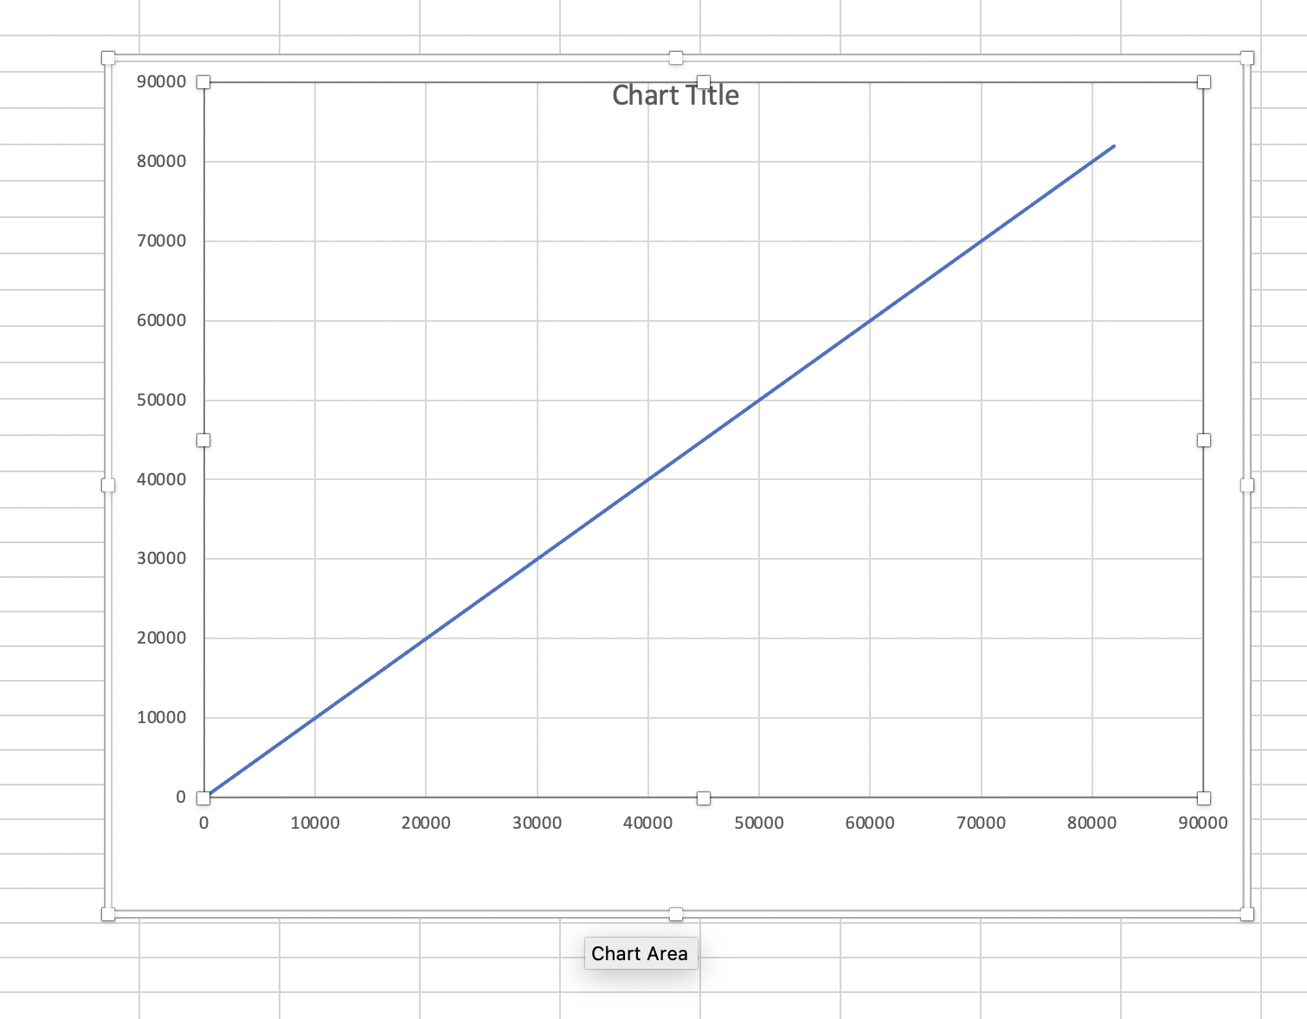

X Axis=n

Y Axis=m

**UNIT TEST:**

